# Brayton Cycle Model Report

## Introduction

This report describes a Python-based **Ideal** **Air-Standard Brayton Cycle** simulation.

This cycle is widely used in gas turbine engines. The program calculates state conditions, work, heat transfer, efficiency, and power output based on user-provided initial conditions.

## The ideal Air-Standard Brayton Cycle

Figure 1 Ideal Air-Standard Brayton Cycle (Moran, Shapiro, Boettner, & Bailey, 2014)

The ideal standard-air Brayton cycle consists of four main stages:

* **Isentropic Compression**: Ambient air is compressed in the compressor, increasing pressure and temperature.
* **Isobaric Heat Addition**: The compressed air absorbs heat in the combustion chamber, raising its temperature.
* **Isentropic Expansion**: The hot, high-pressure air expands through the turbine, producing work output.
* **Isobaric Heat Rejection**: The remaining heat is expelled, returning the air to its initial state.

Assumptions of the ideal Air-Standard Brayton Cycle

An idealization often used in the study of open gas turbine power plants is that of an air-standard analysis. In an air-standard analysis two assumptions are always made (Moran, Shapiro, Boettner, & Bailey, 2014):

* The working fluid is air, which behaves as an ideal gas.
* The temperature rise that would be brought about by combustion is accomplished by a heat transfer from an external source.
* Irreversibilities as air circulate through the various components are ignored.

## Model architecture

In this section, the **Brayton Cycle Model Architecture Diagram** is presented to provide a visual representation of the thermodynamic processes involved in the cycle.

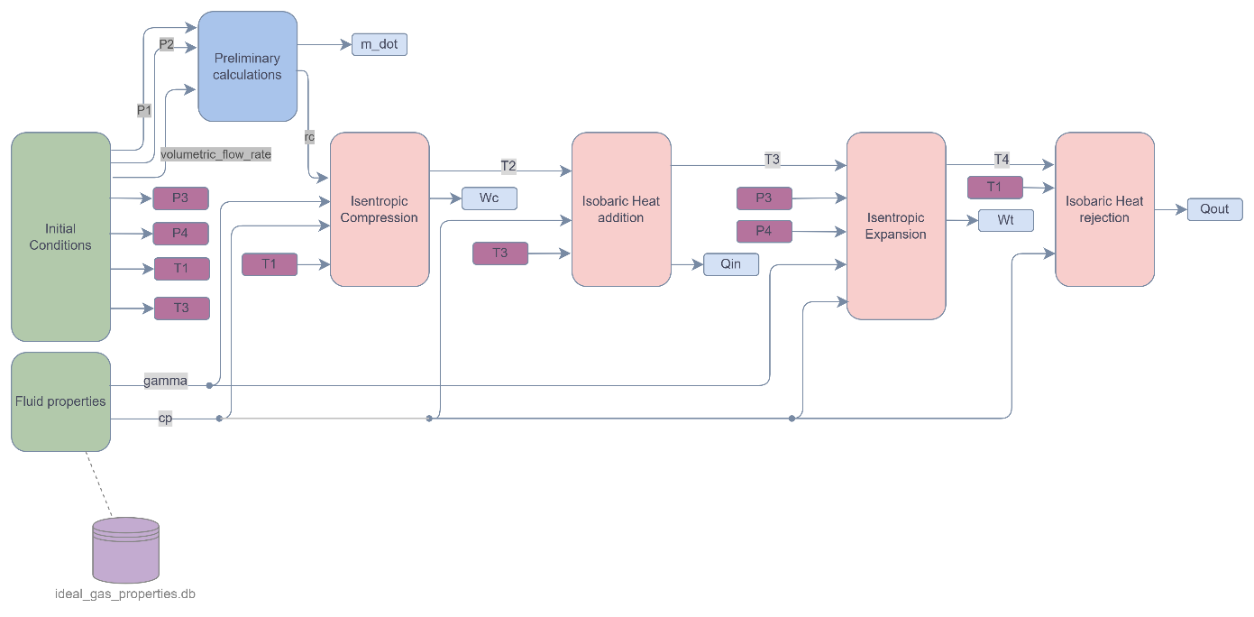

Figure 2 Brayton Cycle model architecture (author)

## Code Structure

The code is organized into modular functions sourced from different imported modules:

* initial_conditions:
  + Defines pressure (P1, P2, P3, P4), temperature (T1, T3), and volumetric flow rate.
* fluid_properties:
  + get_cp_cv: Retrieves specific heat values (Cp and Cv) from ideal_gas_properties database.
* general_functions:
  + compression_ratio: Calculates pressure compression ratio.
  + volumetric_to_mass_flow_rate: Converts volumetric to mass flow rate.
* thermodynamic_processes:
  + isentropic_compression: Computes temperature T2 and compressor work.
  + isobaric_heat_addition: Computes heat input Qin across constant pressure.
  + isentropic_expansion: Computes temperature T4 and turbine work Wt.
  + isobaric_heat_rejection: Computes heat rejection Qout.

## Thermodynamic Process Breakdown

The code implements four key thermodynamic processes:

1. **Isentropic Compression**
   * Uses compression ratio (rc) and initial temperature (T1) to compute final temperature (T2) and compressor work input (Wc).
   * Requires specific heat capacity at constant pressure (cp) for property calculations.
   * Takes gamma (γ) as an input to apply entropy relations in the isentropic process.
2. **Isobaric Heat Addition**
   * Uses initial temperature (T2) and final temperature (T3) to compute the heat added (Qin) during the isobaric heating phase.
   * Requires specific heat capacity at constant pressure (cp) for property calculations.
   * Returns Qin, representing the heat input for subsequent turbine stages.
3. **Isentropic Expansion**
   * Uses initial pressure (P3) and final pressure (P4) along with initial temperature (T3) to compute the final temperature (T4) after expansion.
   * Requires specific heat capacity at constant pressure (cp) for property calculations.
   * Takes gamma (γ) as an input to apply entropy relations in the isentropic process.
   * Computes work output (Wt) generated by the turbine.
4. **Isobaric Heat Rejection**
   * Uses initial temperature (T1) and final temperature (T4) to compute the heat rejected (Qout) during the isobaric cooling phase.
   * Requires specific heat capacity at constant pressure (cp) for property calculations.
   * Returns Qout, representing the expelled heat for further thermodynamic analysis.

## Performance Metrics

The simulation determines key cycle performance metrics (Moran, Shapiro, Boettner, & Bailey, 2014):

* **Net Work Output:**
  + Wnet_work_based = Wt - Wc (direct work output calculation).
  + Wnet_heat_based = Qin + Qout (energy balance method).
* **Efficiency Calculation:**
  + efficiency = Wnet_work_based / Qin
* **Power Output:**
  + power_output = Wnet_work_based * m_dot
* **Back Work Ratio (BWR):**
  + bwr = Wc / Wt

## Results & Improvements

The code systematically computes and prints:

* **Stage-wise temperatures, work values, and heat transfer values**.
* **Net power output and efficiency**.

Possible Enhancements:

* **Error Handling:** Improve missing temperature checks with fallback values.
* **Modularization:** Simplify repeated calls to get_cp_cv() with a helper function.
* **Graphical Output:** Implement **Matplotlib** to visualize efficiency trends.

## Conclusion

This Brayton Cycle model efficiently simulates gas turbine performance and provides insights into thermodynamic properties. With minor refinements, it can serve as a robust tool for cycle analysis.